How to add a second display on (Mac, PC) Adding a second display for pc Step 1- Examine your monitor and verify all of the ports that you have for your monitor and make sure you have at least a vga port, dvi port, or hdmi. If you have a newer monitor then you should have a hdmi port Step 2- Take a hdmi cable and take one in and plug it into your monitor and take the other end and plug into your second display. If you’re display is new then you may use a displayport but if it is older then you may have to use a hdmi to vga cable or hdmi to vga. Step 3- Right click on your desktop home screen and select screen resolution and it will take you to a window that shows the displays that are detected Step 4- To make sure that you have good quality to your second display make sure that your resolution is set to recommended and make sure you have the option extend desktop to this display option checked. After that you want to click apply and you should be connected to your second display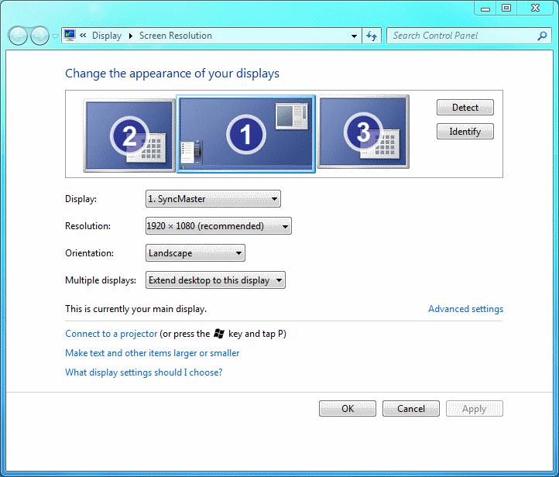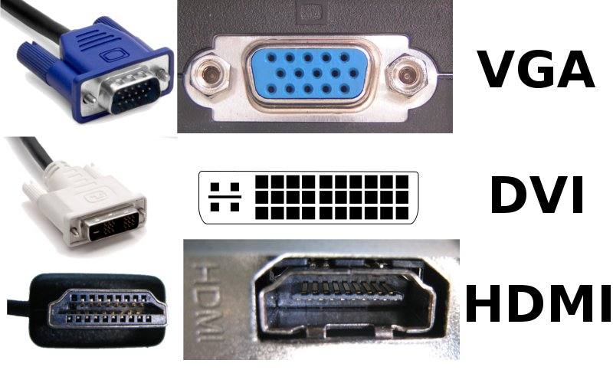

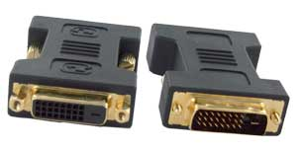

How to add second display on a Mac Step 1- Gather up the appropriate accessories when trying to connect a second display to your mac. Because of apple’s weird arrangement or adapters you will have to pick up Mini displayport to hdmi adapter or a mini displayport to dvi adapter. The picture on the left is a mini displayport to dvi adapter while the picture on the right is a mini displayport to hdmi adapter To know which cables to buy you want to figure out whether or not the cable is a male or female. Apple adapters are female adapters which mean they have holes and not spikes but in cases where your adapter from your second display is also female you will need a male to female adapter. Step 2- After you finish gathering all of your accessories set up your second display, turn it on and connect it to the mini display port. Automatically the mac OS should recognize the second display but if not click on the apple menu on the top left corner and go to system preferences and display and then arrangements. Step 3- Once you get to the arrangements tab a configuration window will pop up and what you want to do is disable mirroring displays and you will do this by unchecking the mirror displays box. 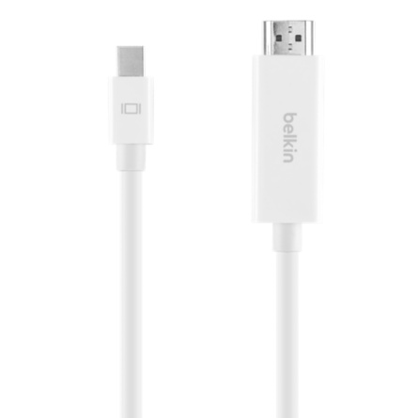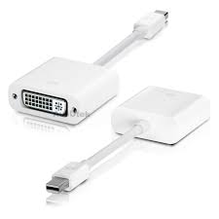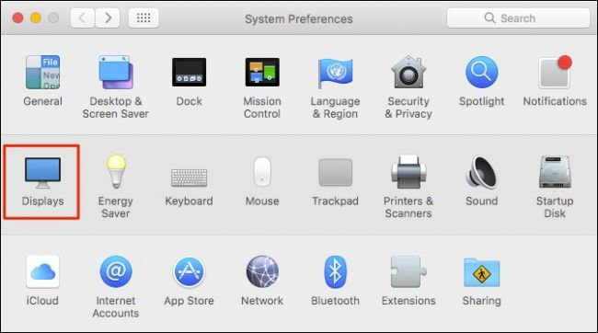

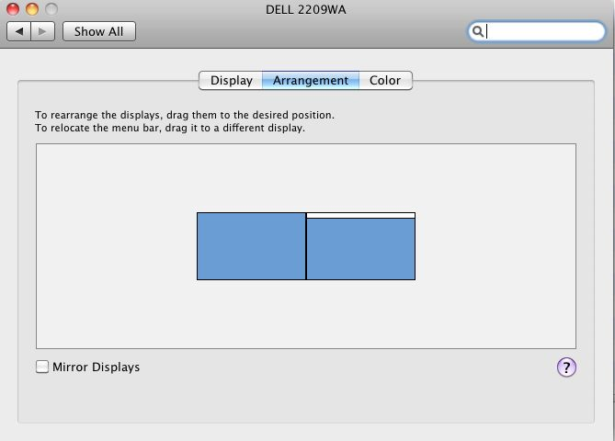

Step 4- For a second or two the screens will go black and when both of the displays pop back up you will get two different displays that you can access freely. By default mac os will detect the monitor and automatically connect and set the display size and resolution but if you want to adjust it even more you can go to the apple menu system preferences and display and you can easily be able to change the resolution.